**INSTALLATION REQUIREMENTS** :

* JDK
* Maven

**MAVEN COMMAND TO EXECUTE:**

mvn test verify -Dcucumber.options="--tags @auto"

**RESTAPI LOGS:**

\\src\\test\\java\\Logs\ \APILog

**REPORT LOCATION:**

//target//report//cucumber-html-reports//report-feature_4277810500.html

**Evidence1 - BUILD SUCCESS**

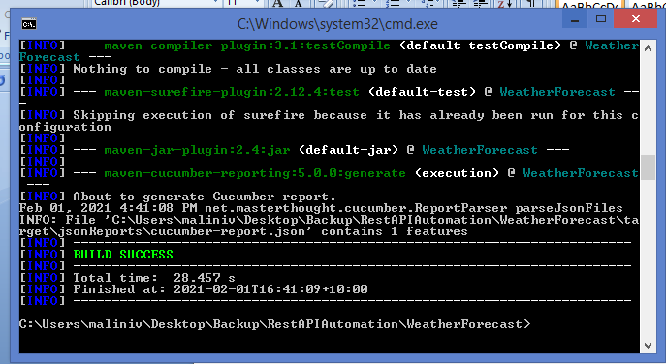

**Evidence2 - REPORT:**

